Name – Gayatri Dnyaneshwar Avhad

Roll no- 231071007

Batch – A

Assignment -3

6

Aim :

Task -1 : Read and understand SOLID principles of software development.

Write a sample code for each principle.

1. Single Responsibility Principle (SRP)

Each class should have only one reason to change, meaning it should have only one

responsibility or task. Imagine a User class that handles both data storage (saving to a

database) and email communication (sending a welcome email). According to SRP,

these are two distinct responsibilities: data handling and email communication. By

splitting them into separate classes (e.g., UserDatabase for storage and EmailService

for communication), each class now has a single, clear responsibility, which makes

them easier to maintain and reuse

Code :

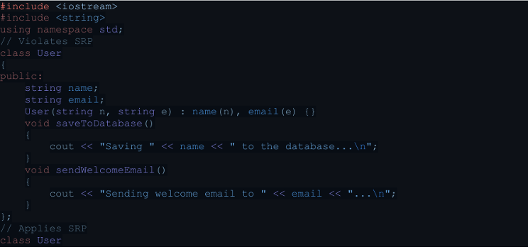

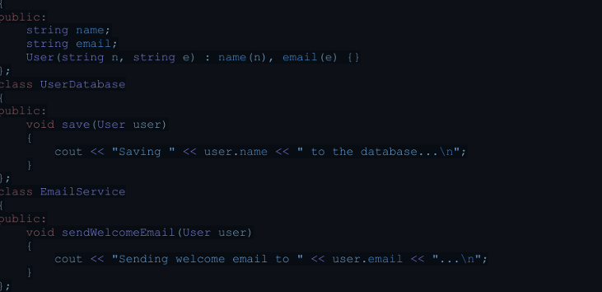

2.Open/ClosedPrinciple(OCP)

Software entities(classes ,modules, functions)should be open for extension but closed

formodification. Suppose we have anotification system with a Notificationbaseclass.We

want the system to be open to newnotification types like SMS,pushnotifications,oremails

withoutmodifyingtheoriginalNotificationclass.BydefiningabaseNotificationclass

andimplementingsubclasseslike‘EmailNotification’and‘SMSNotification’,weadd

newtypesofnotificationswithoutalteringtheexistingones.Thisdesignisscalable and

minimisescodealterations, there by maintainingstability

Code:

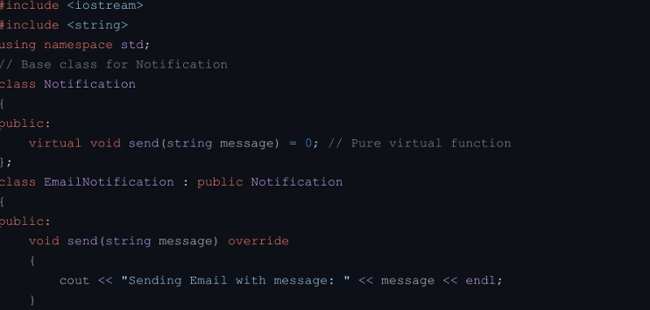

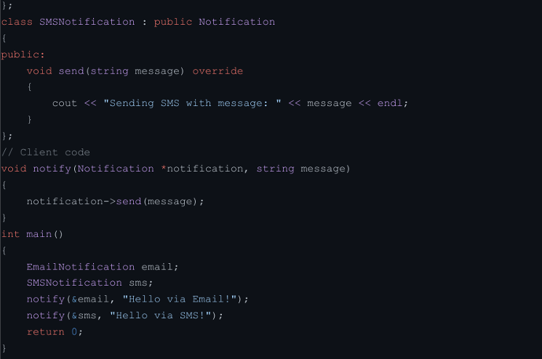

Experiment Task 1: Consider grades received by 20 students, like AA, AB, BB, ..., FF of each

student.

Computer the Longest common sequence of grades among students.

Algorithm :

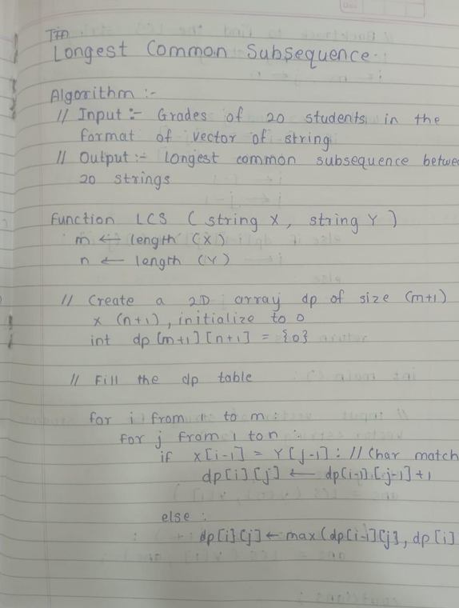

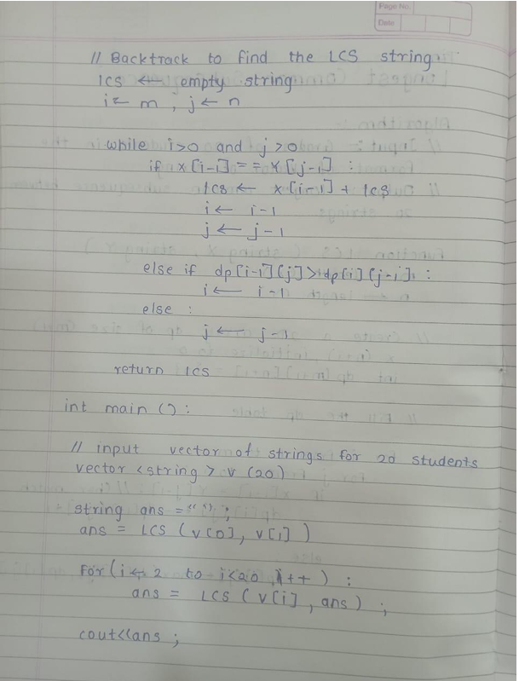

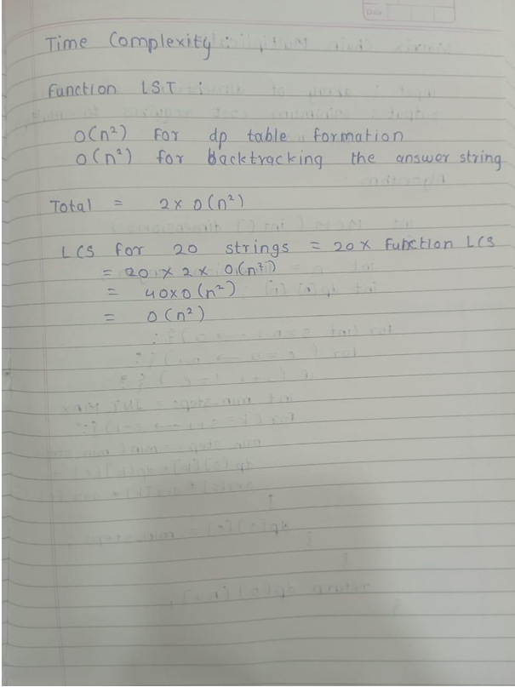

Code and output:

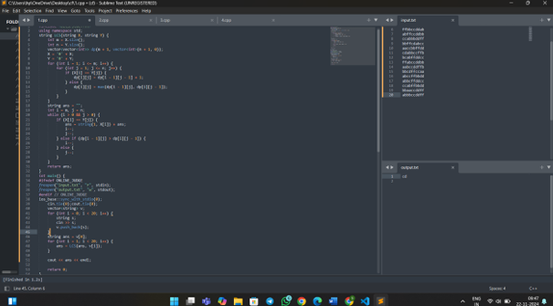

Experiment Task 2: Consider meteorological data like temperature, dew point, wind

direction, wind speed, cloud cover, cloud layer(s) for each city. This data is available in two

dimensional array for a week. Assuming all tables are compatible for multiplication. You have

to implement the matrix chain multiplication algorithm to find fastest way to complete the

matrices multiplication to achieve timely predication.

Algorithm :

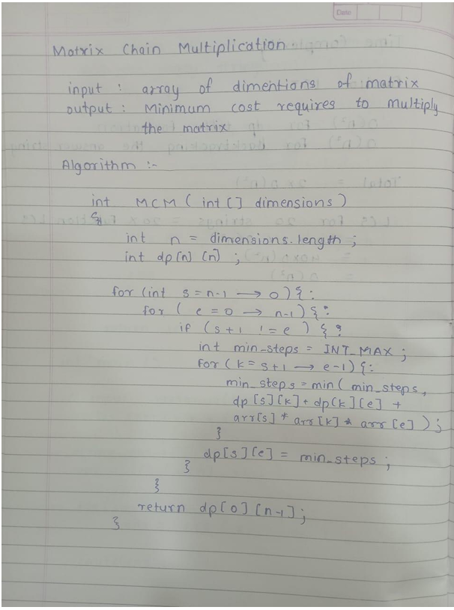

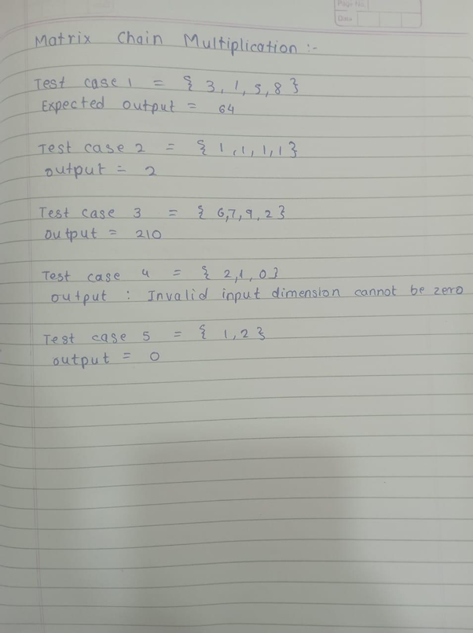

Code :

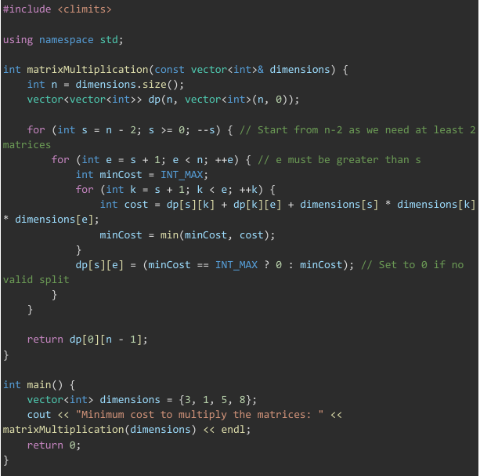

Output :

